**HACKATHON 3 – DAY 7**

**SAMRA JAMAL**

**ENVIRONMENT VARIABLE SECURITY AND CONFIGURATION**

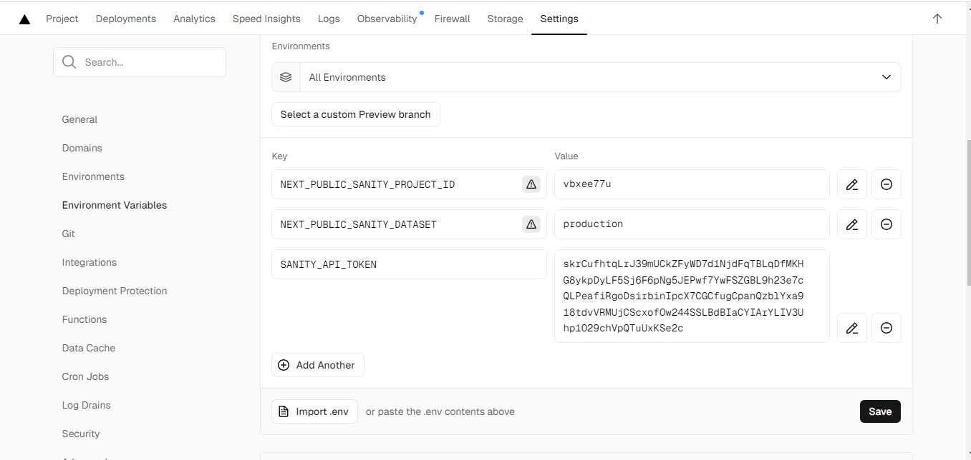

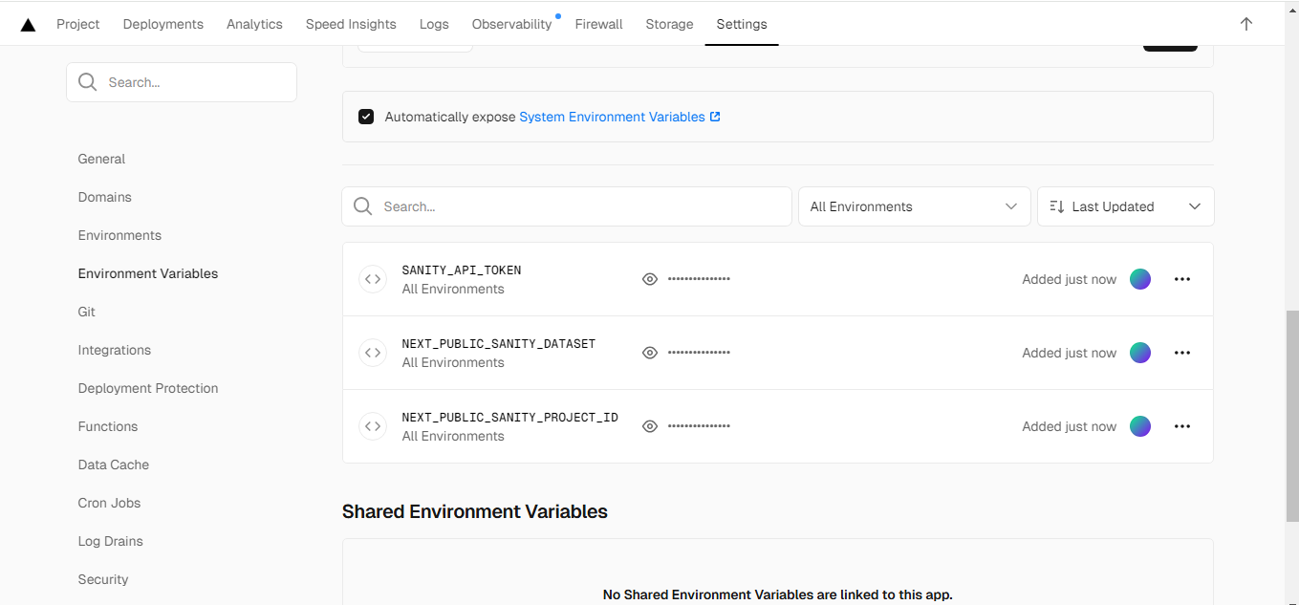

**.SSL AND HTTPS ENABLED**

[**https://e-commerce-marketplace-opal.vercel.app/**](https://e-commerce-marketplace-opal.vercel.app/)

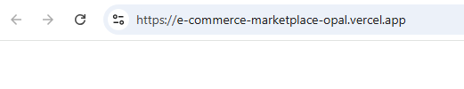

**PERFORMANCE OPTIMIZATION**

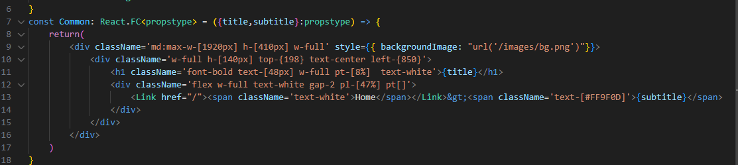

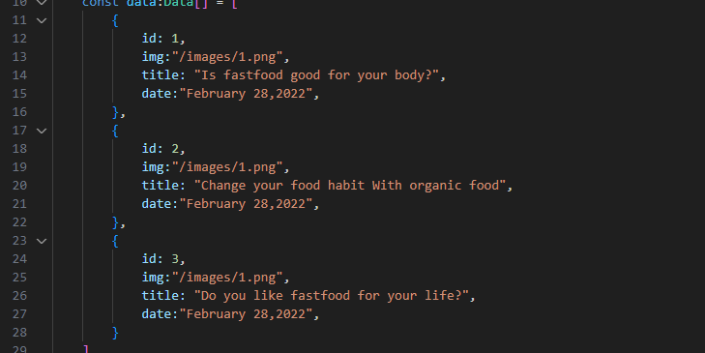

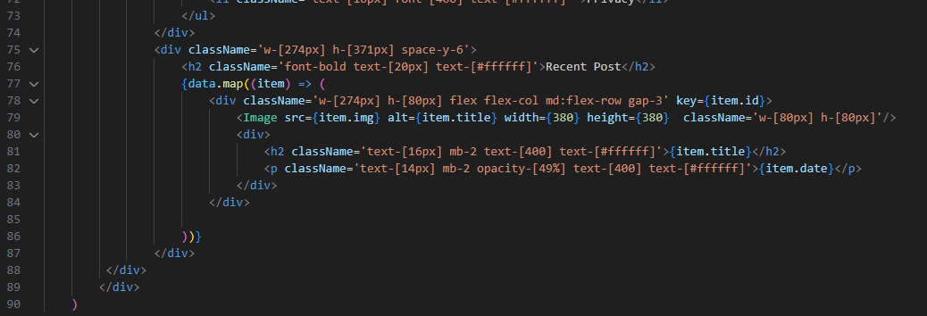

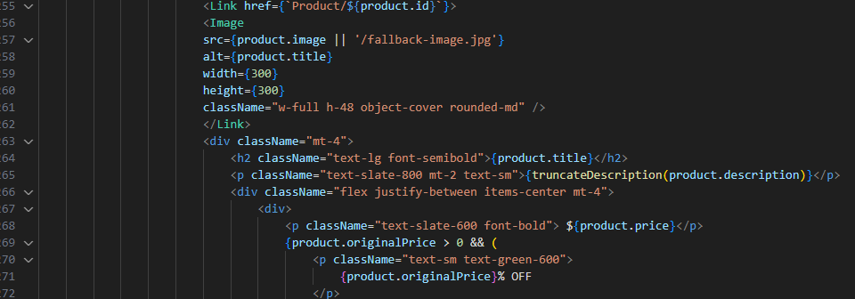

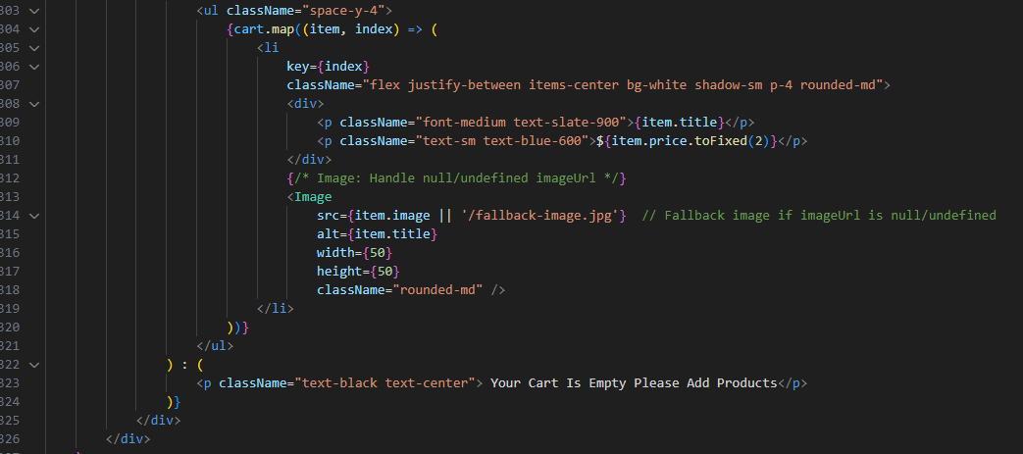

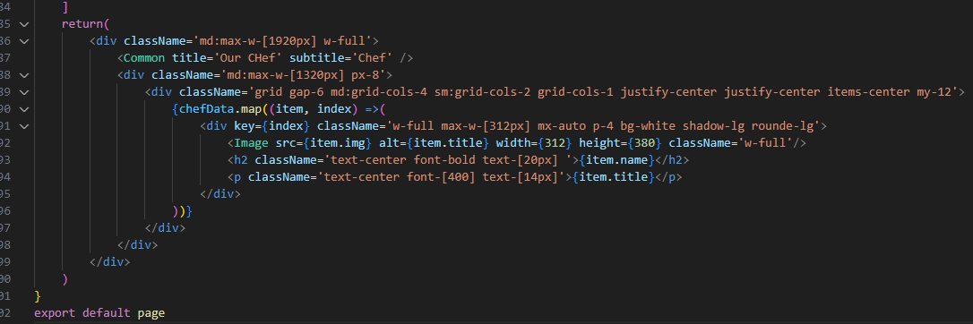

**npm install @sentry/nextjs**

